Seeing an explanation

Imagine you are in a room.
It is lit by sunlight and you are looking at a book on the table.

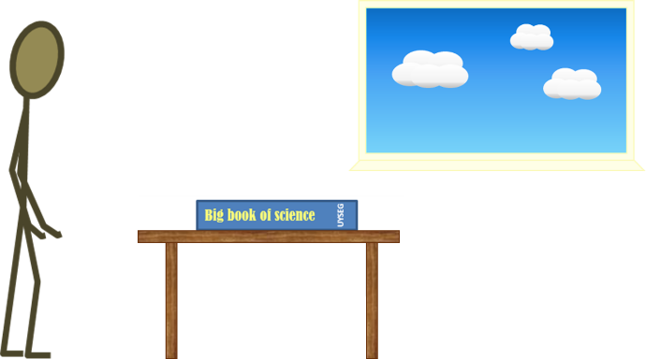

How do you see the book?
Pick one statement in each row to explain how.
1 | Light travels out in all directions from the Sun.
2 | Sunlight passes through the window into the room.
3 | Some light from the Sun falls on the book | Some light from the Sun goes into my eyes. |  | Sunlight fills the room and makes it bright.
4 | Light is given out by the book. | Light is scattered by the book. |  | Light is soaked up by the book.
5 | As a result, some light travels from the book to my eyes |  | At the same time, some light goes from my eyes to the book.
6 | I see the book because it is lit up. |  | I see the book because this light enters my eyes.

Physics > Big idea PSL: Sound, light and waves > Topic PSL2: How we see > Key concept PSL2.1: The ‘passive eye’ model of vision
Diagnostic question
Seeing an explanation

Overview
Learning focus: | Objects are seen when light reflects off them into our eyes.
Observable learning outcome: | Explain how non-luminous objects can be seen when sunlight reflects off them and into our eyes.
Question type: | Explanation story
Key words: | Sunlight, absorbed, emitted, scattered

What does the research say?
To help students develop the scientific explanation that non-luminous object are seen because some of the light scattered off them enters the eye, it can help to remind students of how light reflects off a mirror before considering how objects reflect light from an obvious light source. Students can then be guided to apply this understanding to explain how we see non-luminous objects in more diffuse light (Allen, 2014; Driver et al., 1994).
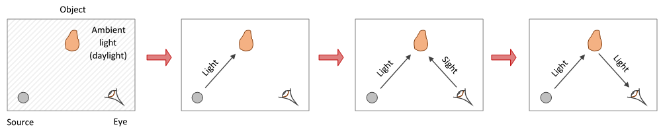
The progression in conceptions of vision encountered among 13- to 14-year-olds, towards that of a physicist (Guesne, 1985)
Studies by Ramada and Driver (1989) and Andersson and Karrqvist (1983) found that just 31% of fifteen-year-olds (n=456 and n=166 respectively) described how a girl sees a book using the idea of light going from book to eye. Almost as many either used the non-explanation that ‘light helps us to see’ or gave no explanation at all. Anderson and Smith’s study (1986) showed that 6% of 10- to 11-year olds in their sample held the scientific view of vision, Boyes and Stanisstreet’s study (1991) showed this increases to 10% of 11- to 12-year-olds and 33% of over-14s.
This question investigates students’ understanding of how a non-luminous object is seen in diffuse sunlight.
Ways to use this question
This task is intended for discussion in pairs or small groups. It is best done as a pencil and paper exercise.
Students should read the statements and follow the instructions on the worksheet. Listening in to the conversations of each group will often give you insights into how your students are thinking. Each member of a group should be able to report back to the class.
Feedback from each group can be used, with careful teacher questioning, to bring out a clear description or explanation of the science.
Differentiation
The quality of the discussions can be improved with a careful selection of groups; or by allocating specific roles to students in the each group. For example, you may choose to select a student with strong prior knowledge as the scribe, and forbid them from contributing any of their own answers. They may question the others and only write down what they have been told. This strategy encourages contributions from more members of each group.
NB in any class, small group discussions typically improve over time and a persistence with this strategy is often very successful in the medium to long term.
Expected answers
1 | Light travels out in all directions from the Sun.
2 | Sunlight passes through the window into the room.
3 | Some light from the Sun falls on the book | Some light from the Sun goes into my eyes. |  | Sunlight fills the room and makes it bright.
4 | Light is emitted by the book. | Light is scattered by the book. |  | Light is absorbed by the book.
5 | As a result, some light travels from the book to my eyes |  | At the same time, some light goes from my eyes to the book.
6 | I see the book because it is lit up. |  | I see the book because this light enters my eyes.

How to respond - what next?
On row 3: some light from the Sun enters the eyes, but does not carry information from the book. If this light is too bright it can overwhelm what is being looked at, so we can’t see clearly.
The light filling the room is a poetic description and it appears this way to us, as light reflects off all the surfaces into our eyes. Light is not like a gas which spreads to fill a volume. At night light doesn’t disperse from a room when the light is turned off.
On row 4 the book does not emit light because it is not luminous. It does absorb light, but this light cannot then reach the eyes.
‘Light goes from my eyes to the book’ – our eyes do not emit light, or we would see other people’s eyes glowing at night!
If students have misunderstandings about how the book can be seen in sunlight, it can help to repeat the question thinking about a very small window. This may help students to make the connection that links this situation to how they can see the book when a lamp shines on it.
The following BEST ‘response activities’ could be used in follow-up to this diagnostic question:
- Response activity: How do we see?
- Response activity: Explaining seeing
Acknowledgments
Developed by Peter Fairhurst (UYSEG), from York Science activity 3.2d: Seeing an explanation.
Images: Peter Fairhurst (UYSEG), based on those in York Science activity 3.2d: Seeing an explanation.
References
Allen, M. (2014). Misconceptions in Primary Science, Second edn Berkshire, UK: Open University Press.
Anderson, C. W. and Smith, E. L. (1986). Childrens' conceptions of light and colour: developing the concept of unseen rays. Annual meeting of the American Educational Research Association. Montreal, Canada.
Andersson, B. and Karrqvist, C. (1983). How Swedish pupils aged 12-15 years understand light and its properties. European Journal of Science Education, 5(4), 387-402.
Boyes, E. and Stanisstreet, M. (1991). Development of pupils' ideas of hearing and seeing - the path of light and sound. Research in Science and Technology Education, 9, 223-44.
Driver, R., et al. (1994). Making Sense of Secondary Science: Research into Children's Ideas, London, UK: Routledge.
Guesne, E. (1985). Light. In Driver, R., Guesne, E. & Tiberghien, A. (eds.) Children's Ideas in Science. Milton Keynes: Open University Press.
Ramadas, J. and Driver, R. (1989). Aspects of Secondary Students' Ideas About Light, Leeds: University of Leeds Centre for Studies in Science and Mathematics Education.

